Creation of repository :

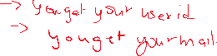



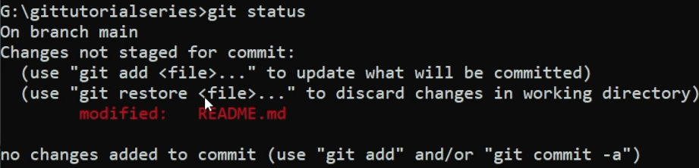

They are 2 important thing s we can modify the file or restore the file.









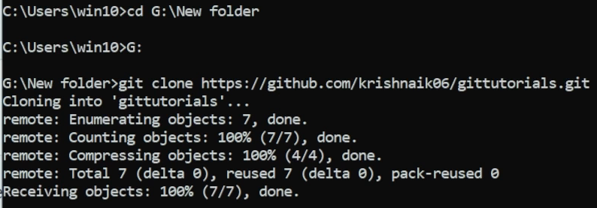



We can also add code directly without any software :













